Sae:full bias=true train:half bias=false sae:20epoch

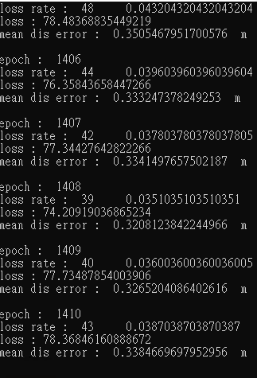

Sae:full bias=true train:half bias=false sae:30epoch

